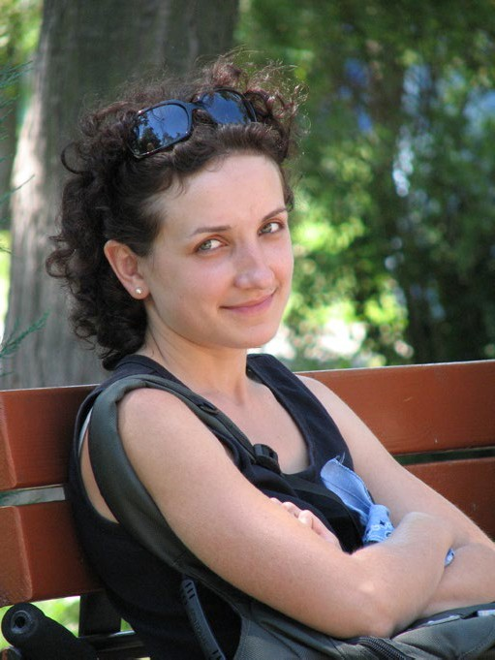
Which Plate Boundary?

“My name is Catherine and I live in San Francisco, United States.
I’ve lived here all my life and I’m used to the earthquakes. They’re mostly small ones. Sometimes, you don’t even feel them because they’re so slight, but you might hear about it on the news or from a friend. I’ve known them be a little bit more violent as well, lasting quite a few seconds and making the building sway.
In 1989, there was a deadly earthquake here that killed 67 people and caused $5billion in damage. That was one of my first memories. I can remember my parents being really afraid. There was lots of screaming while the house shook and my mum lost one of her friends. That earthquake lasted 15 seconds but it seemed a lot longer.
But what I’m really frightened of is the one some people call “The Big One”. If a massive earthquake hits this city, there’s a concern that much of San Francisco could be flattened. That could leave thousands dead and millions of people without a home. I pray it will not happen, but some think the next “Big One” could hit at any time.
At least we don’t get any volcanoes, though. We’re lucky in that sense. If we had to put up with volcanoes as well as earthquakes, it would be even more reason to worry.”

Complete the following sentences:
Catherine lives in , which is on a plate boundary.
I know this because

In the box below, draw a sketch to show what happens at the plate boundary where Catherine lives. Include as much detail as you can in the sketch. Add labels and annotations to explain the processes taking place

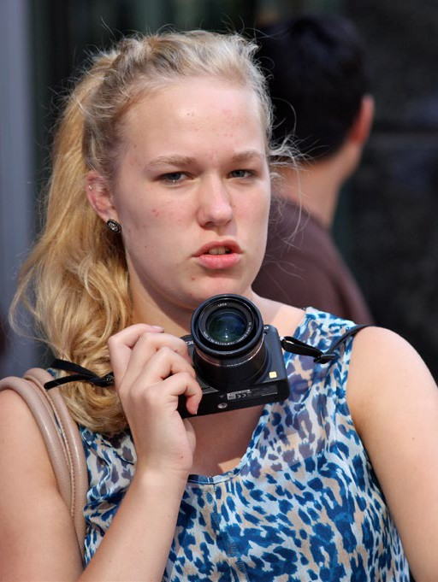

“Hello there, my name is Ruby. I live in Reykjavik, Iceland.
We have lots of volcanoes here in Iceland. Sometimes, when they erupt, you can get pretty close to them and watch the lava spewing out. It’s really beautiful and usually really safe – if it’s not safe, the government stop people going too close.
But the volcanoes can also cause problems here. When Eyjafjallajökull erupted in 2010, it sent an ash cloud high into the atmosphere. That can make it dangerous for planes because the ash can affect their engines. The airport had to close for several days, meaning nobody could get out of the country or arrive here.
We get earthquakes here, too. Thankfully, though, they’re usually small ones. Sometimes, you can’t feel them but when you can they don’t tend to last too long. They sometimes cause small amounts of damage, but not often.”

Complete the following sentences:
Ruby lives in , which is on a plate boundary.
I know this because

In the box below, draw a sketch to show what happens at the plate boundary where Ruby lives. Include as much detail as you can in the sketch. Add labels and annotations to explain the processes taking place.



“Hey! I’m Fernando and I live in L’Aquilla, Italy.
Back in 2009, my house was destroyed by an earthquake that hit L’Aquilla. I was lying in my bed and heard a sudden banging noise and then realised that all my books and CDs were falling from the shelf as the house shook. I and my family managed to get out of the house just in time because some of the wall collapsed. We were not allowed back in.
Over 300 people were killed by the quake. 1500 people were injured and up to 10 000 buildings were damaged. Several shops and other businesses were destroyed on that day. Years later, some parts of L’Aquilla were still sealed off. It’s an old, historic city and it really showed just how powerful earthquakes can be in Italy.
We also have volcanoes in Italy that can be very ferocious. You may have heard of Mount Etna on the island of Sicily. That one erupts quite often and can damage buildings and roads. Then there’s Vesuvius near the city of Naples. That was the one that erupted and destroyed the Roman city of Pompeii. It’s not shown any signs of action since World War Two, but some people reckon it’s due another one soon.
Life in Italy carries on normally day-to-day. But you never know when the next earthquake or volcano will strike.

Complete the following sentences:
Fernando lives in , which is on a plate boundary.
I know this because

In the box below, draw a sketch to show what happens at the plate boundary where Fernando lives. Include as much detail as you can in the sketch. Add labels and annotations to explain the processes taking place.

